Back-to-School Back-to-PTA Conference
Tuesday, September 27, 2016, from 9:00am am to 3:00pm
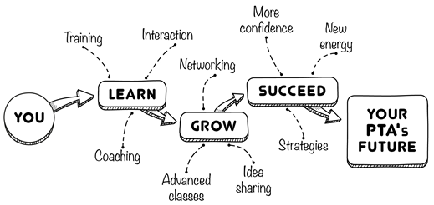
NEW LOCATION!!!! FLAGET CONFERENCE CENTER
1935 Lewiston Drive in Louisville KY 40216 (off Dixie Hwy)

Price includes:

- Light Breakfast
- Lunch
- Access to Over 20 Vendors
- Counts Towards Board Training
- Opportunity to Participate in Silent Auction
- Door Prize Giveaways
- Legitimate PTA Expense

Multiple Workshops:

- Presidents What You Need to Know
- Treasurer Nuts & Bolts
- Nutrition
- Reflections
- SBDM
- Watch DOGS
- Middle/High PTSA
- Awards & Scholarships
- FRYSC’s and PTAs Working Together

PRICE: **These prices are good until Friday, September 23, 2016 by 4:00pm
1 Person – 2 People | 3 People & Up
$18.00 per person | $15.00 per person

QUESTIONS: Contact Autumn Neagle at autumn@argo-networks.com or call (502) 718-2590

RETURN BELOW TO: 15TH DISTRICT PTA, P.O. BOX 35444 IN LOUISVILLE KY 40233-5444

PTA/PTSA Name: _________________________________________________________________________

Attendees: 1. ______________________________________ 2. ____________________________________

3. ______________________________________ 4. ____________________________________

5. ______________________________________ 6. ____________________________________

Contact Phone: ___________________________ Contact Email: __________________________________

Number of Paid Attendees: __________ Total Enclosed: $_____________ Ck# _______________
_ _ _ _ _ _ _ _ _ _ _ _ _ _ _ _ _ _ _ _ _ _ _ _ _ _ _ _ _ _ _ _ _ _ _ _ _ _ _ _ _ _ _ _ _ _ _ _ _ _ _ _ _ _ _ _ _ _ _
PAYMENT SECTION To be completed by 15th District PTA
HOW PAID: _______ CASH _______ CHECK # _______________ AMOUNT PAID? $_______________________
RECEIVED BY ___________________________________________________ TITLE ______________________________

