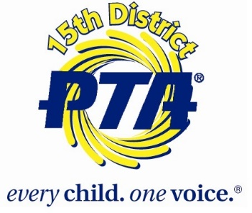
15th District PTA
Awards Dinner Agenda
May 10, 2018
(Not Final - Subject to Change –
Also this is expanded with details for those looking at Title 1 Fund Approval)

Welcome – Starts at 6:30 pm

Student Inspiration - Alexis Reece

Pledge - Frost Student Council

Greetings - Cherie Dimar - KY PTA President

Greetings - Diane Porter - Chairman, JCBOE

Greetings - Dr. Pollio - Superintendent

Business Meeting – 10 minutes or less
  - Includes appointing a audit committee for minutes and financial review, treasurer report, and showcasing some highlights of the year including CAP, Reflections, and spelling bee.
Dinner Served
- Key Speaker - Mr. Kumar Rashad – 20-25 minutes
  - Speaking about Parent Engagement
  - Key Points - How to engage non-engaged parents, how engaged parents can reach non-engaged parents, how to engage community support from community partners.

Recognition and Awards
  - Scholarships - Will be giving out scholarships to High School Seniors
  - Awards for - Hall of Fame, Special Projects, Website, Newsletter, Social Media, Outstanding Volunteer Participation, Outstanding Volunteer, Male Participation, and Advocacy Award. Each award has short explanation of what the individual or PTA did. Many people get ideas from what others have done.

Speaker -Kimberly Cecil-Jones - 10 minutes
  - Key Points - Membership Challenge and how it plays into our base of advocacy

Membership Campaign Awards

Membership Awards

Closing Remarks - and ends at 8:00 pm

We will also have informational tables and displays about
CAP
Spelling Bee
Reflections
Membership
Resource Table - will have information about parent involvement, 15th District PTA, and ways to get involved in your school and community, summer programs, and anything else I can find to place on there. :)

